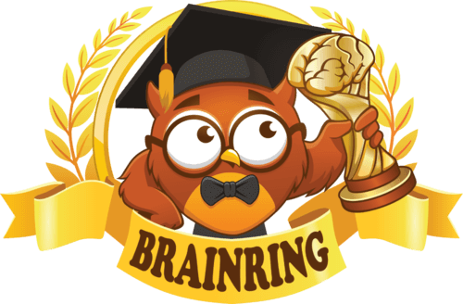
Attention!
Students and teachers in grades 1-11 are invited to take part in the International Educational Competition "Brain Ring 2024 - Spring Session".
🗓️ Participation in the "Brain Ring 2024 - Spring Session" competition is available at any time from 1 to 31 March 2024 inclusive.
🌟 6 competitions in various subjects: English, Maths, Science, Computing, History, Geography.
🎯 The contest goal is to stimulate students' interest and increase motivation to study.
📚 The tasks of varying difficulty correspond to the school curriculum.
🕒 40 minutes to complete all tasks (1 lesson).
🏆 All participants will receive personal diplomas, certificates and "Brain Ring" pens. They will also be able to win other valuable prizes!
💵 Teachers-supervisors of the competition receive certificates of the organiser and a compensation of 30% of the fees of the students they have registered.
🥇All teachers whose students have obtained 1-3 degree diplomas receive certificates confirming their students' achievements.
🏡 Students can take part in competitions at any time that suits them, not only at school but also at home.
🖥️ Participation in the competitions takes place on the website www.brainring.co.uk
💰 One student's participation fee in all competitions — £4.99
🔗 Registration and further information: www.brainring.co.uk

